**Dealing with environment**

[**Reference Link**](https://blog.csdn.net/zhoubangbang1/article/details/99710663?utm_medium=distribute.pc_relevant.none-task-blog-BlogCommendFromMachineLearnPai2-2.control&dist_request_id=1dddbb2a-2d77-4940-bb66-623a67f478ab&depth_1-utm_source=distribute.pc_relevant.none-task-blog-BlogCommendFromMachineLearnPai2-2.control)

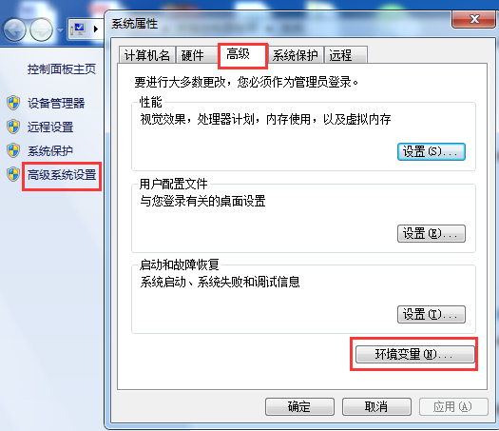

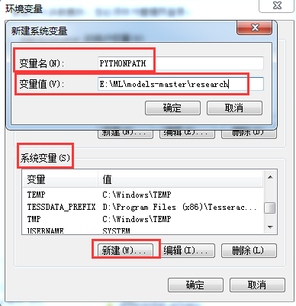

**c: \models\research; c:\models\research\slim**

**INSTALLATION STEPS**

pip install tensorflow-gpu

git clone https://github.com/tensorflow/models.git

conda install -c anaconda protobuf

cd models\research

**Compile protos**

protoc object_detection\protos\*.proto --python_out=.

activate base

pip install cython

pip install git+https://github.com/philferriere/cocoapi.git#subdirectory=PythonAPI

**install** [**visual c++ 2015**](https://go.microsoft.com/fwlink/?LinkId=691126)

copy object_detection\packages\tf2\setup.py .

python -m pip install .

test model

python object_detection\builders\model_builder_tf2_test.py

**Install labelimg**

[Labelimg link](https://github.com/tzutalin/labelImg)

Ensure you downloaded labelimg and are in the labelimg directory

conda install pyqt=5

conda install -c anaconda lxml

pyrcc5 -o libs/resources.py resources.qrc

python labelImg.py

**generate_tfrecord**

to run this and xml_to_csv, they need to be outside the images folder

└─ images/

└─ xml_to_csv

└─ generate_tfrecord

└─ train.record  
└─ test.record

**Model Training**

object_detection

└─ images/

├ train

├ test

└─ training   
 ├ label_map.pbtxt  
 ├ model.config

└─ model

└─ training   
 ├ label_map.pbtxt  
 ├ model.config